# Karnov Group RISMA controls: How to complete Controls

Karnov Group has implemented the GRC (Governance, Risk Management and Controls) system RISMA to document Internal controls.

This means that you will receive automatic notifications by email when deadlines for your controls are nearing and when they have been passed, and that you will be submitting information and documentation in the RISMA interface instead of a spreadsheet. Your controls will then be reviewed and accepted in the RISMA platform, and all history can be found here for future reference.

You will find that your controls are set up and ordered as you know them already and that you may find further supporting evidence in the control flow.

## Notifications

You will receive notifications when you are added as a responsible or reviewer to a control; when the traffic light turns to yellow (this is a new feature and will be turned on 2-3 weeks before deadline); the day before the deadline; and then once a week until the control is completed. If you have several controls with the same deadline you will only receive one collated notification with several links to the controls in it.

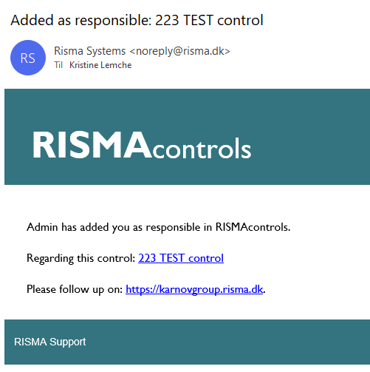

## Login and MyPage

Login to the platform here: <https://karnovgroup.risma.dk/> with your email-address and the password that has been supplied to you. You will be prompted to change your password at first login. Select a password with more than 8 characters and special characters.

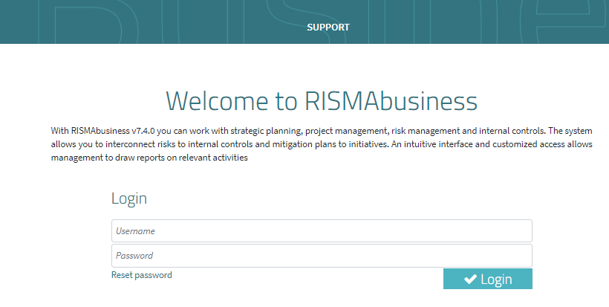

If you forget your password, you can always reset it by clicking the “reset password” field below the password box. You will then receive an email with further instructions for resetting.

After login, you will land on the MyControls Page. This is also where you will land if you click the link in the RISMA notification mail. This is an overview of all the controls for which you are responsible. The controls will be sorted by deadline, so controls closest to deadline will be placed at the top of the list. You can filter, sort and search in your controls by using the search options at the top of the page.

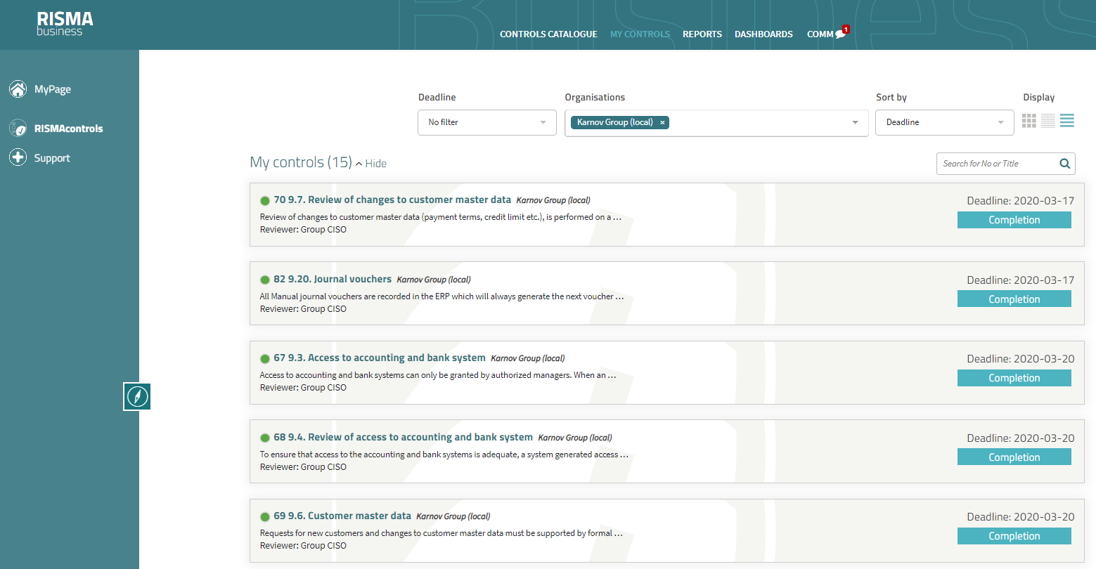

If you have more than one control, you can complete your controls directly from the MyPage view one by one. Once you have completed the control, it will be relegated to the bottom of the list.

## How to complete a control

Click the “Completion” button on the Control to begin the completion flow.

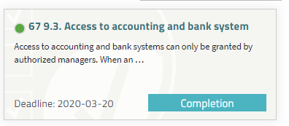

A data entry page comes up where you will be required to enter all the relevant data for your control.

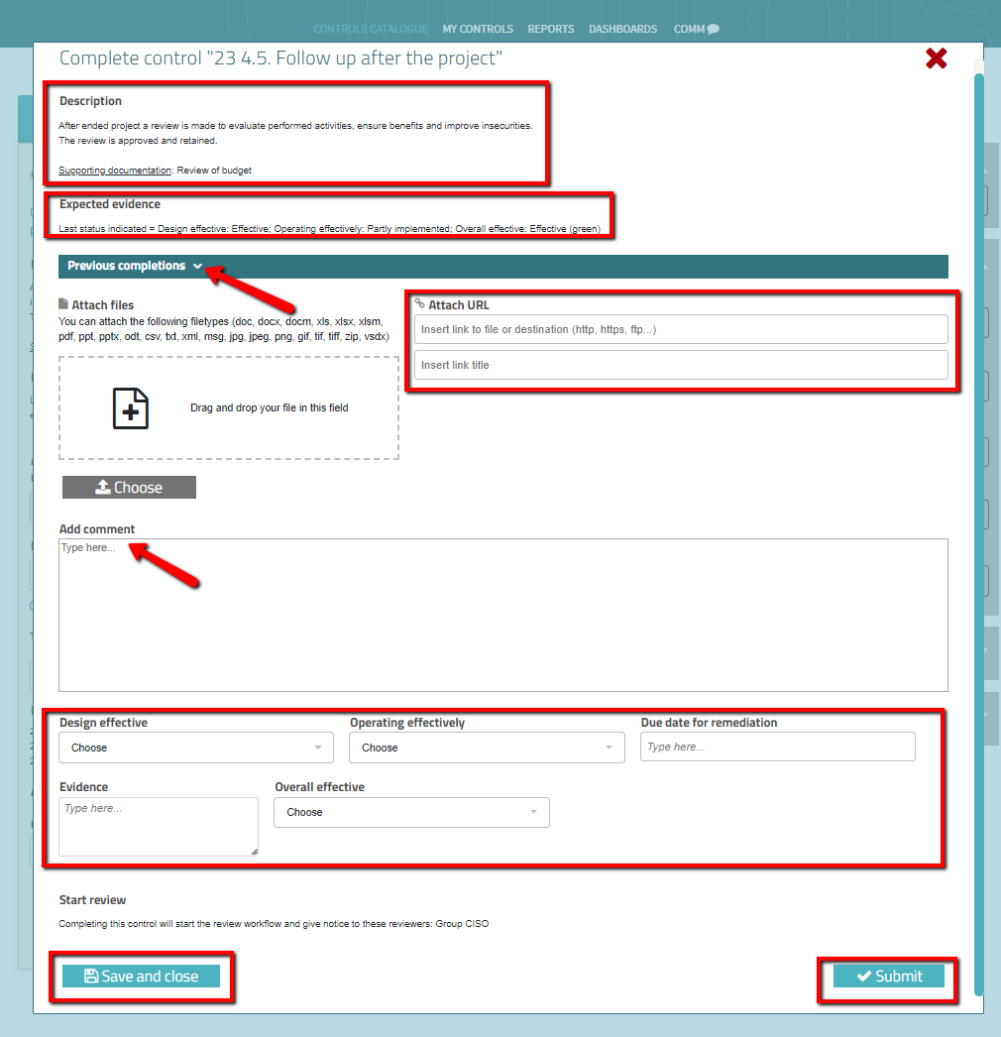

## Description field

In the description field, you will find a description of the control itself and what you are supposed to do. You will also find a reference to where you can find further supporting documentation.

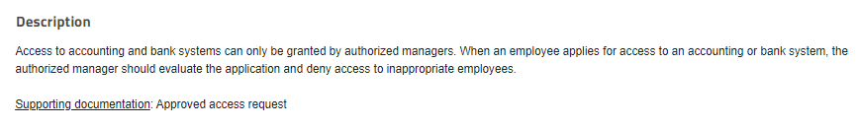

## Expected Evidence field

In the expected evidence field, you can see what the last results were when the control was last completed. Use these as a reference for what to select in the drop-down menu at the bottom of the data entry page.

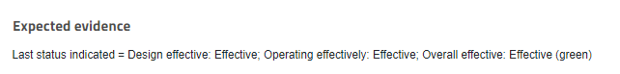

## Previous completions box

In the previous completions box, you will find an overview of the results from the previous completions of the control. Refer to these to see what the history of the control was previously.

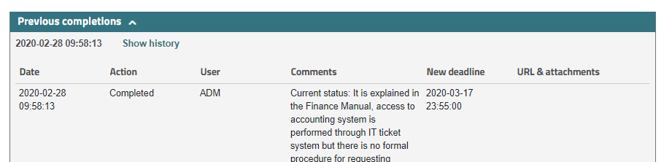

## Attachment option

If you have further documentation, you can attach a link to where the documentation is stored, ie Sharepoint or file drives. You must insert the link and supply it with a suitable title.

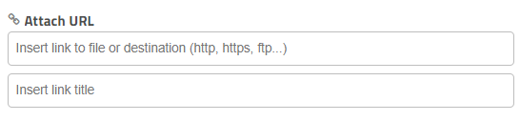

***DO NOT USE THE ATTACH FILES OPTION***

## Comments free text field

Enter your Comments and Actions in the Comments free text field.

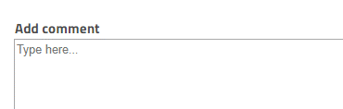

IMPORTANT: You must enter text in the comments free text field and additional link to further documentation – otherwise the control cannot be completed.

## Drop down single select fields

In the drop-down boxes you must select whether your control has been design effective, Operating effectively, the due date for remediation (Only number formats dd-mm-yyyy), evidence and overall effective. ***Please refer to the Expected Evidence field to see the data from the last completion.***

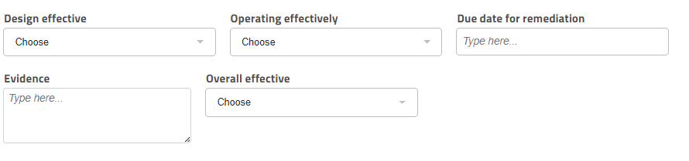

## Save and close

If you wish to exit the completion window before submitting the control, you can press the “Save and close” button. This saves all entered information and you can continue your work at a later stage. This is especially relevant for controls which are continuous, or transaction driven, but which are only submitted quarterly or annually.

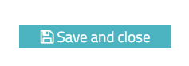

## Submit

Once you have entered all the information and you are sure all is entered correctly, submit the control. This closes and locks the control and triggers the review process and you will not be able to change any data afterwards unless the reviewer rejects the control and reopens it.

The control is now completed, and you will receive a notification again next time the control is due.

